1 run......

Downloading: 100%

464/464 [00:00<00:00, 16.9kB/s]

Downloading: 100%

270M/270M [00:06<00:00, 43.7MB/s]

training 1 epoch...

8.821123361587524 seconds used......

1 training finished! average train loss: 0.9557702267169952

evaluating...

Confusion matrix, without normalization

[[ 0 2 39]

[ 0 0 95]

[ 0 11 703]]

Normalized confusion matrix

[[0. 0.04878049 0.95121951]

[0. 0. 1. ]

[0. 0.01540616 0.98459384]]

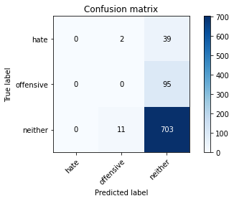

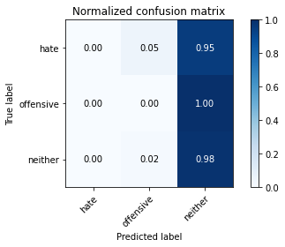

/opt/conda/lib/python3.7/site-packages/sklearn/metrics/_classification.py:1245: UndefinedMetricWarning: Precision and F-score are ill-defined and being set to 0.0 in labels with no predicted samples. Use `zero_division` parameter to control this behavior.

_warn_prf(average, modifier, msg_start, len(result))

/opt/conda/lib/python3.7/site-packages/sklearn/metrics/_classification.py:1245: UndefinedMetricWarning: Precision and F-score are ill-defined and being set to 0.0 in labels with no predicted samples. Use `zero_division` parameter to control this behavior.

_warn_prf(average, modifier, msg_start, len(result))

/opt/conda/lib/python3.7/site-packages/sklearn/metrics/_classification.py:1245: UndefinedMetricWarning: Precision and F-score are ill-defined and being set to 0.0 in labels with no predicted samples. Use `zero_division` parameter to control this behavior.

_warn_prf(average, modifier, msg_start, len(result))

precision recall f1-score support

hate 0.00 0.00 0.00 41

offensive 0.00 0.00 0.00 95

neither 0.84 0.98 0.91 714

accuracy 0.83 850

macro avg 0.28 0.33 0.30 850

weighted avg 0.71 0.83 0.76 850

average eval_loss: 0.6931110921987268, accuracy: 0.8270588235294117

training 2 epoch...

7.923726797103882 seconds used......

2 training finished! average train loss: 0.8054804396629334

evaluating...

Confusion matrix, without normalization

[[ 0 21 20]

[ 0 47 48]

[ 0 166 548]]

Normalized confusion matrix

[[0. 0.51219512 0.48780488]

[0. 0.49473684 0.50526316]

[0. 0.232493 0.767507 ]]

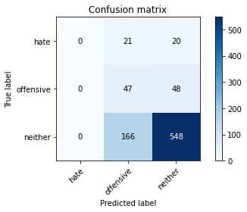

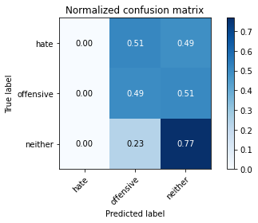

/opt/conda/lib/python3.7/site-packages/sklearn/metrics/_classification.py:1245: UndefinedMetricWarning: Precision and F-score are ill-defined and being set to 0.0 in labels with no predicted samples. Use `zero_division` parameter to control this behavior.

_warn_prf(average, modifier, msg_start, len(result))

/opt/conda/lib/python3.7/site-packages/sklearn/metrics/_classification.py:1245: UndefinedMetricWarning: Precision and F-score are ill-defined and being set to 0.0 in labels with no predicted samples. Use `zero_division` parameter to control this behavior.

_warn_prf(average, modifier, msg_start, len(result))

/opt/conda/lib/python3.7/site-packages/sklearn/metrics/_classification.py:1245: UndefinedMetricWarning: Precision and F-score are ill-defined and being set to 0.0 in labels with no predicted samples. Use `zero_division` parameter to control this behavior.

_warn_prf(average, modifier, msg_start, len(result))

precision recall f1-score support

hate 0.00 0.00 0.00 41

offensive 0.20 0.49 0.29 95

neither 0.89 0.77 0.82 714

accuracy 0.70 850

macro avg 0.36 0.42 0.37 850

weighted avg 0.77 0.70 0.72 850

average eval_loss: 0.7002524009277654, accuracy: 0.7

training 3 epoch...

7.887318849563599 seconds used......

3 training finished! average train loss: 0.6293497180938721

evaluating...

Confusion matrix, without normalization

[[ 0 16 25]

[ 1 32 62]

[ 4 105 605]]

Normalized confusion matrix

[[0. 0.3902439 0.6097561 ]

[0.01052632 0.33684211 0.65263158]

[0.00560224 0.14705882 0.84733894]]

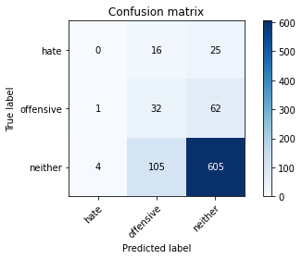

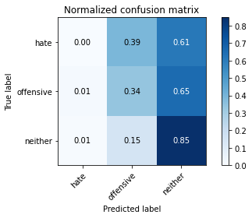

precision recall f1-score support

hate 0.00 0.00 0.00 41

offensive 0.21 0.34 0.26 95

neither 0.87 0.85 0.86 714

accuracy 0.75 850

macro avg 0.36 0.39 0.37 850

weighted avg 0.76 0.75 0.75 850

average eval_loss: 0.5768329786613237, accuracy: 0.7494117647058823

training 4 epoch...

7.939022779464722 seconds used......

4 training finished! average train loss: 0.40599543914198877

evaluating...

Confusion matrix, without normalization

[[ 14 5 22]

[ 14 31 50]

[ 66 82 566]]

Normalized confusion matrix

[[0.34146341 0.12195122 0.53658537]

[0.14736842 0.32631579 0.52631579]

[0.09243697 0.11484594 0.79271709]]

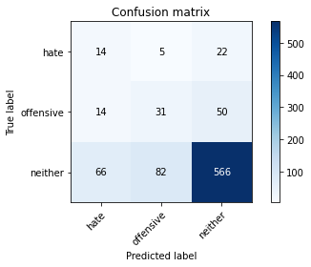

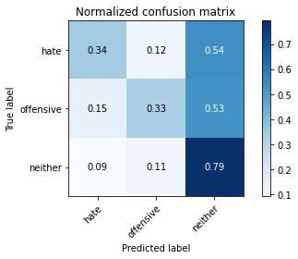

precision recall f1-score support

hate 0.15 0.34 0.21 41

offensive 0.26 0.33 0.29 95

neither 0.89 0.79 0.84 714

accuracy 0.72 850

macro avg 0.43 0.49 0.45 850

weighted avg 0.78 0.72 0.75 850

average eval_loss: 0.7080522870514975, accuracy: 0.7188235294117648

training 5 epoch...

7.9024505615234375 seconds used......

5 training finished! average train loss: 0.2503316347301006

evaluating...

Confusion matrix, without normalization

[[ 4 18 19]

[ 5 47 43]

[ 22 141 551]]

Normalized confusion matrix

[[0.09756098 0.43902439 0.46341463]

[0.05263158 0.49473684 0.45263158]

[0.03081232 0.19747899 0.77170868]]

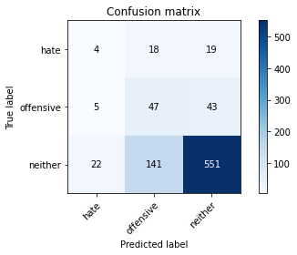

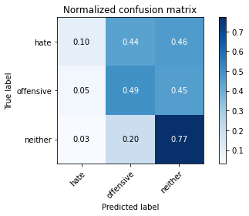

precision recall f1-score support

hate 0.13 0.10 0.11 41

offensive 0.23 0.49 0.31 95

neither 0.90 0.77 0.83 714

accuracy 0.71 850

macro avg 0.42 0.45 0.42 850

weighted avg 0.79 0.71 0.74 850

average eval_loss: 0.7681458005031874, accuracy: 0.7082352941176471

training 6 epoch...

7.8677778244018555 seconds used......

6 training finished! average train loss: 0.09945345565676689

evaluating...

Confusion matrix, without normalization

[[ 5 11 25]

[ 5 23 67]

[ 12 71 631]]

Normalized confusion matrix

[[0.12195122 0.26829268 0.6097561 ]

[0.05263158 0.24210526 0.70526316]

[0.01680672 0.09943978 0.8837535 ]]

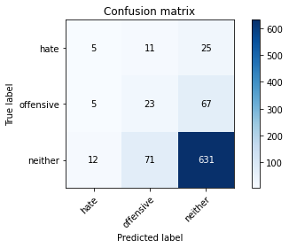

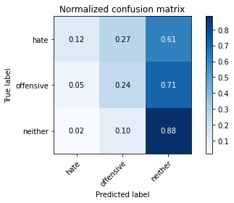

precision recall f1-score support

hate 0.23 0.12 0.16 41

offensive 0.22 0.24 0.23 95

neither 0.87 0.88 0.88 714

accuracy 0.78 850

macro avg 0.44 0.42 0.42 850

weighted avg 0.77 0.78 0.77 850

average eval_loss: 0.7866068271443595, accuracy: 0.7752941176470588

training 7 epoch...

7.939053058624268 seconds used......

7 training finished! average train loss: 0.03947429675608873

evaluating...

Confusion matrix, without normalization

[[ 7 10 24]

[ 7 29 59]

[ 29 75 610]]

Normalized confusion matrix

[[0.17073171 0.24390244 0.58536585]

[0.07368421 0.30526316 0.62105263]

[0.04061625 0.10504202 0.85434174]]

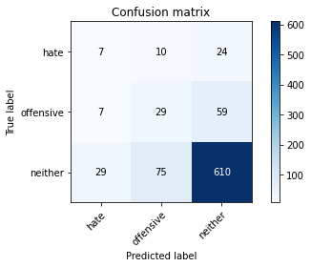

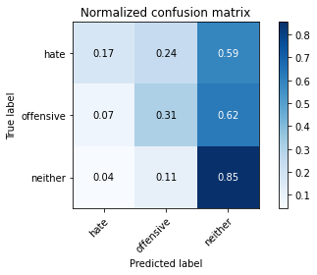

precision recall f1-score support

hate 0.16 0.17 0.17 41

offensive 0.25 0.31 0.28 95

neither 0.88 0.85 0.87 714

accuracy 0.76 850

macro avg 0.43 0.44 0.44 850

weighted avg 0.78 0.76 0.77 850

average eval_loss: 0.881570006739673, accuracy: 0.76

training 8 epoch...

7.8557209968566895 seconds used......

8 training finished! average train loss: 0.013415850717574358

evaluating...

Confusion matrix, without normalization

[[ 8 9 24]

[ 8 36 51]

[ 33 88 593]]

Normalized confusion matrix

[[0.19512195 0.2195122 0.58536585]

[0.08421053 0.37894737 0.53684211]

[0.04621849 0.1232493 0.83053221]]

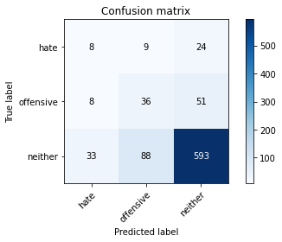

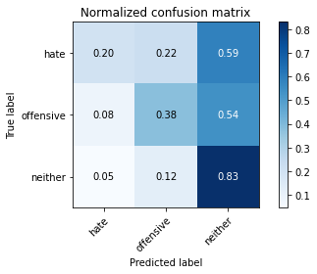

precision recall f1-score support

hate 0.16 0.20 0.18 41

offensive 0.27 0.38 0.32 95

neither 0.89 0.83 0.86 714

accuracy 0.75 850

macro avg 0.44 0.47 0.45 850

weighted avg 0.78 0.75 0.76 850

average eval_loss: 0.9479284629788857, accuracy: 0.7494117647058823

training 9 epoch...

7.885089159011841 seconds used......

9 training finished! average train loss: 0.0094019918423146

evaluating...

Confusion matrix, without normalization

[[ 3 14 24]

[ 2 41 52]

[ 10 113 591]]

Normalized confusion matrix

[[0.07317073 0.34146341 0.58536585]

[0.02105263 0.43157895 0.54736842]

[0.0140056 0.15826331 0.82773109]]

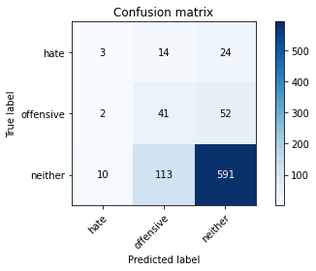

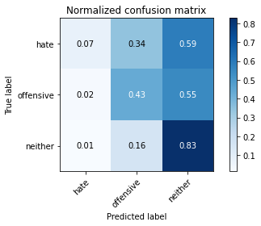

precision recall f1-score support

hate 0.20 0.07 0.11 41

offensive 0.24 0.43 0.31 95

neither 0.89 0.83 0.86 714

accuracy 0.75 850

macro avg 0.44 0.44 0.42 850

weighted avg 0.78 0.75 0.76 850

average eval_loss: 1.0220230498776208, accuracy: 0.7470588235294118

training 10 epoch...

7.891285181045532 seconds used......

10 training finished! average train loss: 0.005453889041673392

evaluating...

Confusion matrix, without normalization

[[ 6 12 23]

[ 11 34 50]

[ 34 96 584]]

Normalized confusion matrix

[[0.14634146 0.29268293 0.56097561]

[0.11578947 0.35789474 0.52631579]

[0.04761905 0.13445378 0.81792717]]

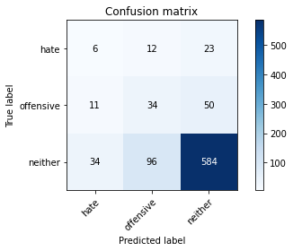

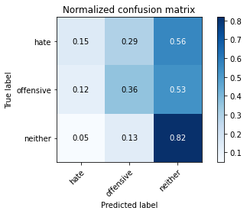

precision recall f1-score support

hate 0.12 0.15 0.13 41

offensive 0.24 0.36 0.29 95

neither 0.89 0.82 0.85 714

accuracy 0.73 850

macro avg 0.42 0.44 0.42 850

weighted avg 0.78 0.73 0.75 850

average eval_loss: 1.0738529891850492, accuracy: 0.7341176470588235

2 run......

training 1 epoch...

7.962913751602173 seconds used......

1 training finished! average train loss: 0.9202146530151367

evaluating...

Confusion matrix, without normalization

[[ 0 27 14]

[ 0 19 76]

[ 0 160 554]]

Normalized confusion matrix

[[0. 0.65853659 0.34146341]

[0. 0.2 0.8 ]

[0. 0.22408964 0.77591036]]

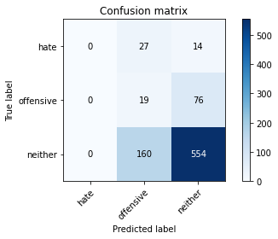

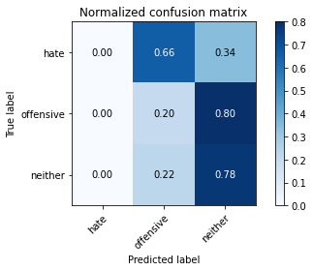

/opt/conda/lib/python3.7/site-packages/sklearn/metrics/_classification.py:1245: UndefinedMetricWarning: Precision and F-score are ill-defined and being set to 0.0 in labels with no predicted samples. Use `zero_division` parameter to control this behavior.

_warn_prf(average, modifier, msg_start, len(result))

/opt/conda/lib/python3.7/site-packages/sklearn/metrics/_classification.py:1245: UndefinedMetricWarning: Precision and F-score are ill-defined and being set to 0.0 in labels with no predicted samples. Use `zero_division` parameter to control this behavior.

_warn_prf(average, modifier, msg_start, len(result))

/opt/conda/lib/python3.7/site-packages/sklearn/metrics/_classification.py:1245: UndefinedMetricWarning: Precision and F-score are ill-defined and being set to 0.0 in labels with no predicted samples. Use `zero_division` parameter to control this behavior.

_warn_prf(average, modifier, msg_start, len(result))

precision recall f1-score support

hate 0.00 0.00 0.00 41

offensive 0.09 0.20 0.13 95

neither 0.86 0.78 0.82 714

accuracy 0.67 850

macro avg 0.32 0.33 0.31 850

weighted avg 0.73 0.67 0.70 850

average eval_loss: 0.7425886832697447, accuracy: 0.6741176470588235

training 2 epoch...

7.987227916717529 seconds used......

2 training finished! average train loss: 0.7767231285572052

evaluating...

Confusion matrix, without normalization

[[ 0 7 34]

[ 0 12 83]

[ 0 33 681]]

Normalized confusion matrix

[[0. 0.17073171 0.82926829]

[0. 0.12631579 0.87368421]

[0. 0.04621849 0.95378151]]

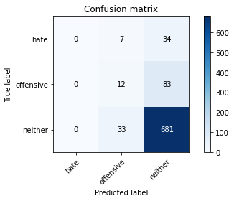

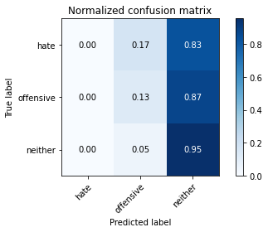

/opt/conda/lib/python3.7/site-packages/sklearn/metrics/_classification.py:1245: UndefinedMetricWarning: Precision and F-score are ill-defined and being set to 0.0 in labels with no predicted samples. Use `zero_division` parameter to control this behavior.

_warn_prf(average, modifier, msg_start, len(result))

/opt/conda/lib/python3.7/site-packages/sklearn/metrics/_classification.py:1245: UndefinedMetricWarning: Precision and F-score are ill-defined and being set to 0.0 in labels with no predicted samples. Use `zero_division` parameter to control this behavior.

_warn_prf(average, modifier, msg_start, len(result))

/opt/conda/lib/python3.7/site-packages/sklearn/metrics/_classification.py:1245: UndefinedMetricWarning: Precision and F-score are ill-defined and being set to 0.0 in labels with no predicted samples. Use `zero_division` parameter to control this behavior.

_warn_prf(average, modifier, msg_start, len(result))

precision recall f1-score support

hate 0.00 0.00 0.00 41

offensive 0.23 0.13 0.16 95

neither 0.85 0.95 0.90 714

accuracy 0.82 850

macro avg 0.36 0.36 0.35 850

weighted avg 0.74 0.82 0.77 850

average eval_loss: 0.5514843801772872, accuracy: 0.8152941176470588

training 3 epoch...

7.914251089096069 seconds used......

3 training finished! average train loss: 0.6108351600170135

evaluating...

Confusion matrix, without normalization

[[ 2 16 23]

[ 4 44 47]

[ 17 89 608]]

Normalized confusion matrix

[[0.04878049 0.3902439 0.56097561]

[0.04210526 0.46315789 0.49473684]

[0.02380952 0.12464986 0.85154062]]

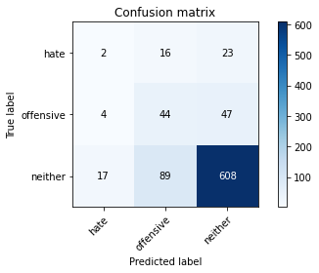

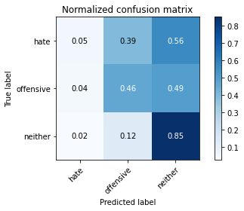

precision recall f1-score support

hate 0.09 0.05 0.06 41

offensive 0.30 0.46 0.36 95

neither 0.90 0.85 0.87 714

accuracy 0.77 850

macro avg 0.43 0.45 0.43 850

weighted avg 0.79 0.77 0.78 850

average eval_loss: 0.6084371932110814, accuracy: 0.7694117647058824

training 4 epoch...

7.904483795166016 seconds used......

4 training finished! average train loss: 0.4037682902812958

evaluating...

Confusion matrix, without normalization

[[ 9 10 22]

[ 12 50 33]

[ 48 104 562]]

Normalized confusion matrix

[[0.2195122 0.24390244 0.53658537]

[0.12631579 0.52631579 0.34736842]

[0.06722689 0.14565826 0.78711485]]

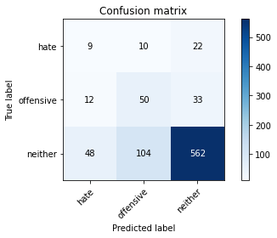

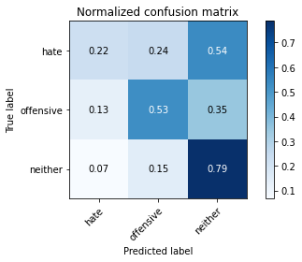

precision recall f1-score support

hate 0.13 0.22 0.16 41

offensive 0.30 0.53 0.39 95

neither 0.91 0.79 0.84 714

accuracy 0.73 850

macro avg 0.45 0.51 0.46 850

weighted avg 0.81 0.73 0.76 850

average eval_loss: 0.6672980987012039, accuracy: 0.7305882352941176

training 5 epoch...

8.00910758972168 seconds used......

5 training finished! average train loss: 0.2518366368114948

evaluating...

Confusion matrix, without normalization

[[ 2 7 32]

[ 4 24 67]

[ 16 58 640]]

Normalized confusion matrix

[[0.04878049 0.17073171 0.7804878 ]

[0.04210526 0.25263158 0.70526316]

[0.02240896 0.08123249 0.89635854]]

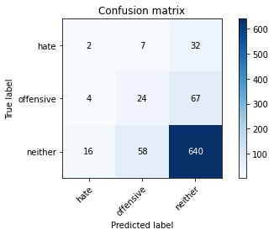

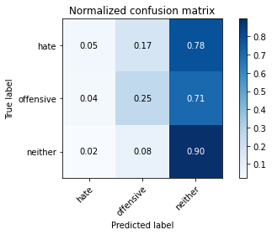

precision recall f1-score support

hate 0.09 0.05 0.06 41

offensive 0.27 0.25 0.26 95

neither 0.87 0.90 0.88 714

accuracy 0.78 850

macro avg 0.41 0.40 0.40 850

weighted avg 0.76 0.78 0.77 850

average eval_loss: 0.6405797205800408, accuracy: 0.7835294117647059

training 6 epoch...

7.919671297073364 seconds used......

6 training finished! average train loss: 0.12812977381050586

evaluating...

Confusion matrix, without normalization

[[ 5 17 19]

[ 7 65 23]

[ 44 130 540]]

Normalized confusion matrix

[[0.12195122 0.41463415 0.46341463]

[0.07368421 0.68421053 0.24210526]

[0.06162465 0.18207283 0.75630252]]

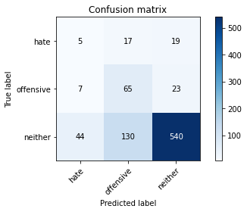

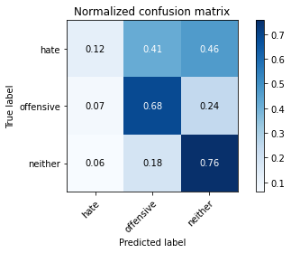

precision recall f1-score support

hate 0.09 0.12 0.10 41

offensive 0.31 0.68 0.42 95

neither 0.93 0.76 0.83 714

accuracy 0.72 850

macro avg 0.44 0.52 0.45 850

weighted avg 0.82 0.72 0.75 850

average eval_loss: 0.8885524941142648, accuracy: 0.7176470588235294

training 7 epoch...

7.901708364486694 seconds used......

7 training finished! average train loss: 0.057028777822852136

evaluating...

Confusion matrix, without normalization

[[ 13 7 21]

[ 15 46 34]

[ 71 94 549]]

Normalized confusion matrix

[[0.31707317 0.17073171 0.51219512]

[0.15789474 0.48421053 0.35789474]

[0.09943978 0.13165266 0.76890756]]

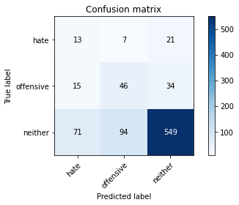

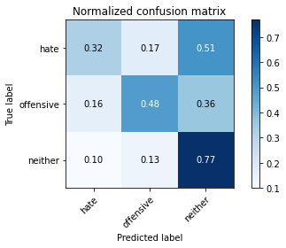

precision recall f1-score support

hate 0.13 0.32 0.19 41

offensive 0.31 0.48 0.38 95

neither 0.91 0.77 0.83 714

accuracy 0.72 850

macro avg 0.45 0.52 0.47 850

weighted avg 0.80 0.72 0.75 850

average eval_loss: 0.9291451028710621, accuracy: 0.7152941176470589

training 8 epoch...

7.923083543777466 seconds used......

8 training finished! average train loss: 0.018596770847216247

evaluating...

Confusion matrix, without normalization

[[ 1 18 22]

[ 4 59 32]

[ 25 133 556]]

Normalized confusion matrix

[[0.02439024 0.43902439 0.53658537]

[0.04210526 0.62105263 0.33684211]

[0.03501401 0.18627451 0.77871148]]

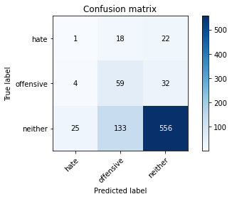

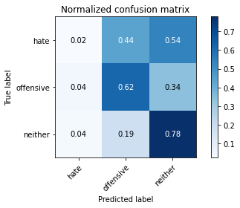

precision recall f1-score support

hate 0.03 0.02 0.03 41

offensive 0.28 0.62 0.39 95

neither 0.91 0.78 0.84 714

accuracy 0.72 850

macro avg 0.41 0.47 0.42 850

weighted avg 0.80 0.72 0.75 850

average eval_loss: 0.9737200499593475, accuracy: 0.7247058823529412

training 9 epoch...

7.867504358291626 seconds used......

9 training finished! average train loss: 0.009727433356456459

evaluating...

Confusion matrix, without normalization

[[ 7 12 22]

[ 13 46 36]

[ 49 96 569]]

Normalized confusion matrix

[[0.17073171 0.29268293 0.53658537]

[0.13684211 0.48421053 0.37894737]

[0.06862745 0.13445378 0.79691877]]

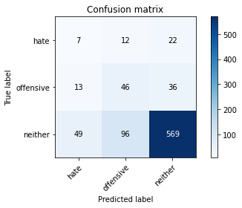

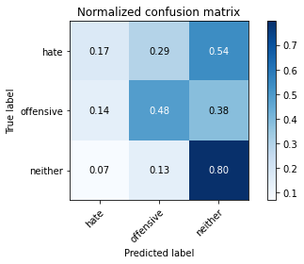

precision recall f1-score support

hate 0.10 0.17 0.13 41

offensive 0.30 0.48 0.37 95

neither 0.91 0.80 0.85 714

accuracy 0.73 850

macro avg 0.44 0.48 0.45 850

weighted avg 0.80 0.73 0.76 850

average eval_loss: 0.9735921827296532, accuracy: 0.731764705882353

training 10 epoch...

7.876497030258179 seconds used......

10 training finished! average train loss: 0.0055518686841242015

evaluating...

Confusion matrix, without normalization

[[ 3 15 23]

[ 7 49 39]

[ 29 99 586]]

Normalized confusion matrix

[[0.07317073 0.36585366 0.56097561]

[0.07368421 0.51578947 0.41052632]

[0.04061625 0.13865546 0.82072829]]

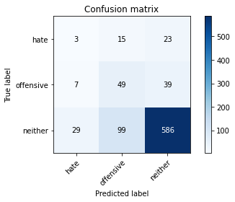

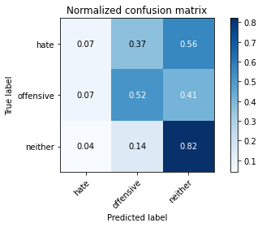

precision recall f1-score support

hate 0.08 0.07 0.07 41

offensive 0.30 0.52 0.38 95

neither 0.90 0.82 0.86 714

accuracy 0.75 850

macro avg 0.43 0.47 0.44 850

weighted avg 0.80 0.75 0.77 850

average eval_loss: 0.9818724497237654, accuracy: 0.7505882352941177

3 run......

training 1 epoch...

7.902897834777832 seconds used......

1 training finished! average train loss: 0.9672036516666412

evaluating...

Confusion matrix, without normalization

[[ 0 29 12]

[ 0 15 80]

[ 0 154 560]]

Normalized confusion matrix

[[0. 0.70731707 0.29268293]

[0. 0.15789474 0.84210526]

[0. 0.21568627 0.78431373]]

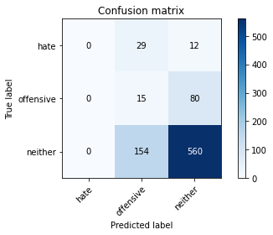

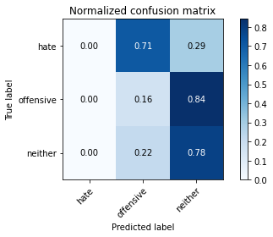

/opt/conda/lib/python3.7/site-packages/sklearn/metrics/_classification.py:1245: UndefinedMetricWarning: Precision and F-score are ill-defined and being set to 0.0 in labels with no predicted samples. Use `zero_division` parameter to control this behavior.

_warn_prf(average, modifier, msg_start, len(result))

/opt/conda/lib/python3.7/site-packages/sklearn/metrics/_classification.py:1245: UndefinedMetricWarning: Precision and F-score are ill-defined and being set to 0.0 in labels with no predicted samples. Use `zero_division` parameter to control this behavior.

_warn_prf(average, modifier, msg_start, len(result))

/opt/conda/lib/python3.7/site-packages/sklearn/metrics/_classification.py:1245: UndefinedMetricWarning: Precision and F-score are ill-defined and being set to 0.0 in labels with no predicted samples. Use `zero_division` parameter to control this behavior.

_warn_prf(average, modifier, msg_start, len(result))

precision recall f1-score support

hate 0.00 0.00 0.00 41

offensive 0.08 0.16 0.10 95

neither 0.86 0.78 0.82 714

accuracy 0.68 850

macro avg 0.31 0.31 0.31 850

weighted avg 0.73 0.68 0.70 850

average eval_loss: 0.7879186189451883, accuracy: 0.6764705882352942

training 2 epoch...

7.9084577560424805 seconds used......

2 training finished! average train loss: 0.8016640263795852

evaluating...

Confusion matrix, without normalization

[[ 1 23 17]

[ 0 60 35]

[ 0 137 577]]

Normalized confusion matrix

[[0.02439024 0.56097561 0.41463415]

[0. 0.63157895 0.36842105]

[0. 0.19187675 0.80812325]]

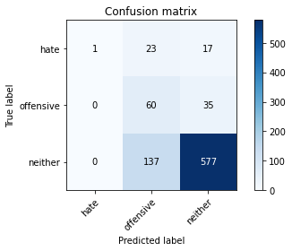

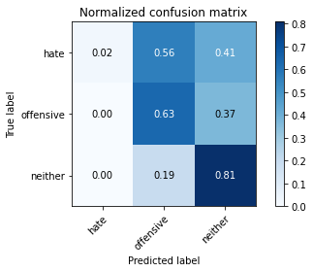

precision recall f1-score support

hate 1.00 0.02 0.05 41

offensive 0.27 0.63 0.38 95

neither 0.92 0.81 0.86 714

accuracy 0.75 850

macro avg 0.73 0.49 0.43 850

weighted avg 0.85 0.75 0.77 850

average eval_loss: 0.6765500123417655, accuracy: 0.7505882352941177

training 3 epoch...

7.967231273651123 seconds used......

3 training finished! average train loss: 0.624395661354065

evaluating...

Confusion matrix, without normalization

[[ 2 23 16]

[ 1 67 27]

[ 7 164 543]]

Normalized confusion matrix

[[0.04878049 0.56097561 0.3902439 ]

[0.01052632 0.70526316 0.28421053]

[0.00980392 0.22969188 0.7605042 ]]

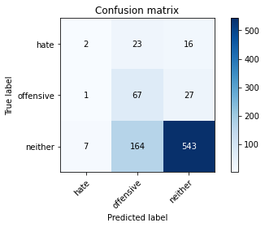

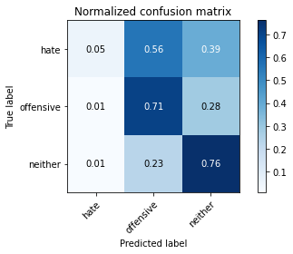

precision recall f1-score support

hate 0.20 0.05 0.08 41

offensive 0.26 0.71 0.38 95

neither 0.93 0.76 0.84 714

accuracy 0.72 850

macro avg 0.46 0.50 0.43 850

weighted avg 0.82 0.72 0.75 850

average eval_loss: 0.6804475844946019, accuracy: 0.72

training 4 epoch...

7.916041135787964 seconds used......

4 training finished! average train loss: 0.41717802673578264

evaluating...

Confusion matrix, without normalization

[[ 6 16 19]

[ 5 43 47]

[ 16 87 611]]

Normalized confusion matrix

[[0.14634146 0.3902439 0.46341463]

[0.05263158 0.45263158 0.49473684]

[0.02240896 0.12184874 0.8557423 ]]

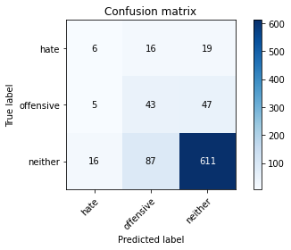

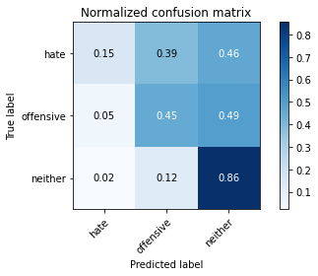

precision recall f1-score support

hate 0.22 0.15 0.18 41

offensive 0.29 0.45 0.36 95

neither 0.90 0.86 0.88 714

accuracy 0.78 850

macro avg 0.47 0.48 0.47 850

weighted avg 0.80 0.78 0.79 850

average eval_loss: 0.5766439752566607, accuracy: 0.7764705882352941

training 5 epoch...

7.935199975967407 seconds used......

5 training finished! average train loss: 0.23203738197684287

evaluating...

Confusion matrix, without normalization

[[ 4 7 30]

[ 7 32 56]

[ 21 54 639]]

Normalized confusion matrix

[[0.09756098 0.17073171 0.73170732]

[0.07368421 0.33684211 0.58947368]

[0.02941176 0.07563025 0.89495798]]

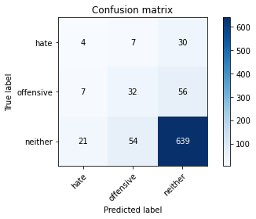

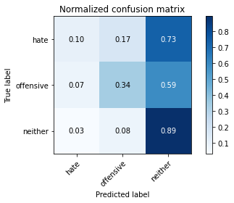

precision recall f1-score support

hate 0.12 0.10 0.11 41

offensive 0.34 0.34 0.34 95

neither 0.88 0.89 0.89 714

accuracy 0.79 850

macro avg 0.45 0.44 0.45 850

weighted avg 0.78 0.79 0.79 850

average eval_loss: 0.6073551886595873, accuracy: 0.7941176470588235

training 6 epoch...

7.949573993682861 seconds used......

6 training finished! average train loss: 0.10798221468925476

evaluating...

Confusion matrix, without normalization

[[ 6 17 18]

[ 6 53 36]

[ 25 100 589]]

Normalized confusion matrix

[[0.14634146 0.41463415 0.43902439]

[0.06315789 0.55789474 0.37894737]

[0.03501401 0.14005602 0.82492997]]

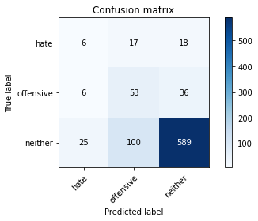

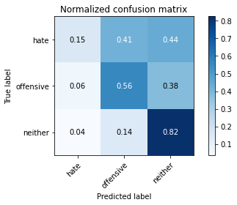

precision recall f1-score support

hate 0.16 0.15 0.15 41

offensive 0.31 0.56 0.40 95

neither 0.92 0.82 0.87 714

accuracy 0.76 850

macro avg 0.46 0.51 0.47 850

weighted avg 0.81 0.76 0.78 850

average eval_loss: 0.7689702251186963, accuracy: 0.7623529411764706

training 7 epoch...

7.886373043060303 seconds used......

7 training finished! average train loss: 0.04344161386601627

evaluating...

Confusion matrix, without normalization

[[ 8 18 15]

[ 6 63 26]

[ 34 131 549]]

Normalized confusion matrix

[[0.19512195 0.43902439 0.36585366]

[0.06315789 0.66315789 0.27368421]

[0.04761905 0.18347339 0.76890756]]

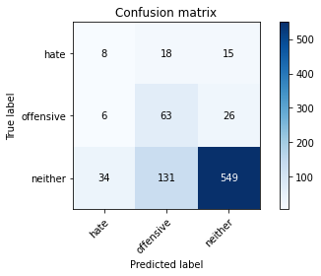

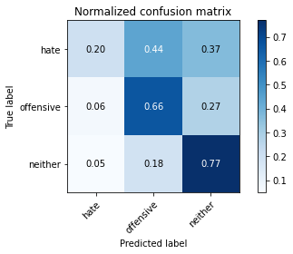

precision recall f1-score support

hate 0.17 0.20 0.18 41

offensive 0.30 0.66 0.41 95

neither 0.93 0.77 0.84 714

accuracy 0.73 850

macro avg 0.46 0.54 0.48 850

weighted avg 0.82 0.73 0.76 850

average eval_loss: 1.0302926222956197, accuracy: 0.7294117647058823

training 8 epoch...

7.898452997207642 seconds used......

8 training finished! average train loss: 0.019080013097263874

evaluating...

Confusion matrix, without normalization

[[ 7 13 21]

[ 8 48 39]

[ 31 87 596]]

Normalized confusion matrix

[[0.17073171 0.31707317 0.51219512]

[0.08421053 0.50526316 0.41052632]

[0.04341737 0.12184874 0.83473389]]

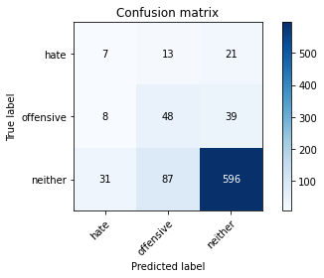

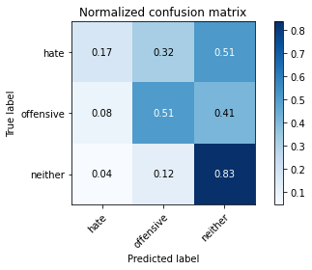

precision recall f1-score support

hate 0.15 0.17 0.16 41

offensive 0.32 0.51 0.40 95

neither 0.91 0.83 0.87 714

accuracy 0.77 850

macro avg 0.46 0.50 0.48 850

weighted avg 0.81 0.77 0.78 850

average eval_loss: 0.9039943221845491, accuracy: 0.7658823529411765

training 9 epoch...

7.918841600418091 seconds used......

9 training finished! average train loss: 0.007502492170315236

evaluating...

Confusion matrix, without normalization

[[ 9 13 19]

[ 8 51 36]

[ 40 105 569]]

Normalized confusion matrix

[[0.2195122 0.31707317 0.46341463]

[0.08421053 0.53684211 0.37894737]

[0.05602241 0.14705882 0.79691877]]

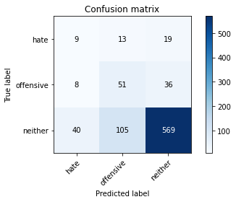

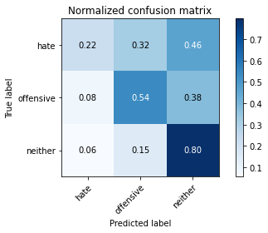

precision recall f1-score support

hate 0.16 0.22 0.18 41

offensive 0.30 0.54 0.39 95

neither 0.91 0.80 0.85 714

accuracy 0.74 850

macro avg 0.46 0.52 0.47 850

weighted avg 0.81 0.74 0.77 850

average eval_loss: 1.0570106131828736, accuracy: 0.74

training 10 epoch...

7.906723976135254 seconds used......

10 training finished! average train loss: 0.008708234664518387

evaluating...

Confusion matrix, without normalization

[[ 6 22 13]

[ 5 72 18]

[ 34 156 524]]

Normalized confusion matrix

[[0.14634146 0.53658537 0.31707317]

[0.05263158 0.75789474 0.18947368]

[0.04761905 0.21848739 0.73389356]]

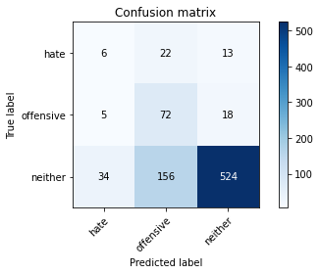

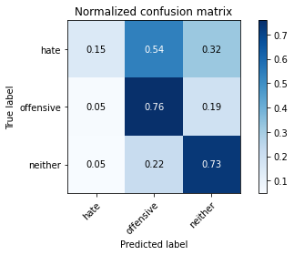

precision recall f1-score support

hate 0.13 0.15 0.14 41

offensive 0.29 0.76 0.42 95

neither 0.94 0.73 0.83 714

accuracy 0.71 850

macro avg 0.46 0.55 0.46 850

weighted avg 0.83 0.71 0.75 850

average eval_loss: 1.361077397961581, accuracy: 0.7082352941176471

4 run......

training 1 epoch...

7.929968595504761 seconds used......

1 training finished! average train loss: 0.9605065405368804

evaluating...

Confusion matrix, without normalization

[[ 0 0 41]

[ 0 0 95]

[ 0 3 711]]

Normalized confusion matrix

[[0. 0. 1. ]

[0. 0. 1. ]

[0. 0.00420168 0.99579832]]

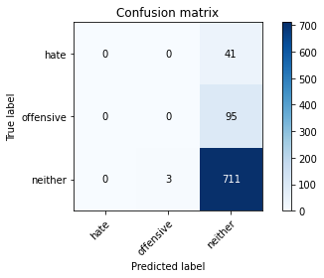

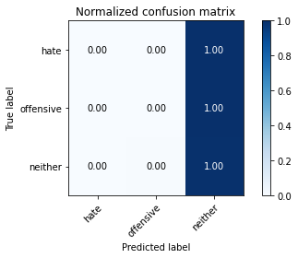

/opt/conda/lib/python3.7/site-packages/sklearn/metrics/_classification.py:1245: UndefinedMetricWarning: Precision and F-score are ill-defined and being set to 0.0 in labels with no predicted samples. Use `zero_division` parameter to control this behavior.

_warn_prf(average, modifier, msg_start, len(result))

/opt/conda/lib/python3.7/site-packages/sklearn/metrics/_classification.py:1245: UndefinedMetricWarning: Precision and F-score are ill-defined and being set to 0.0 in labels with no predicted samples. Use `zero_division` parameter to control this behavior.

_warn_prf(average, modifier, msg_start, len(result))

/opt/conda/lib/python3.7/site-packages/sklearn/metrics/_classification.py:1245: UndefinedMetricWarning: Precision and F-score are ill-defined and being set to 0.0 in labels with no predicted samples. Use `zero_division` parameter to control this behavior.

_warn_prf(average, modifier, msg_start, len(result))

precision recall f1-score support

hate 0.00 0.00 0.00 41

offensive 0.00 0.00 0.00 95

neither 0.84 1.00 0.91 714

accuracy 0.84 850

macro avg 0.28 0.33 0.30 850

weighted avg 0.71 0.84 0.77 850

average eval_loss: 0.6375085531279098, accuracy: 0.8364705882352941

training 2 epoch...

7.864983081817627 seconds used......

2 training finished! average train loss: 0.8064126420021057

evaluating...

Confusion matrix, without normalization

[[ 0 5 36]

[ 0 7 88]

[ 3 33 678]]

Normalized confusion matrix

[[0. 0.12195122 0.87804878]

[0. 0.07368421 0.92631579]

[0.00420168 0.04621849 0.94957983]]

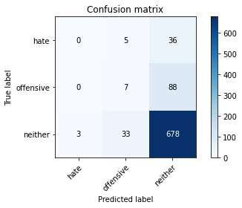

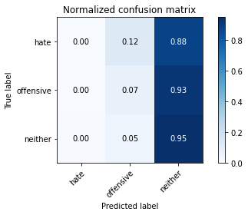

precision recall f1-score support

hate 0.00 0.00 0.00 41

offensive 0.16 0.07 0.10 95

neither 0.85 0.95 0.89 714

accuracy 0.81 850

macro avg 0.33 0.34 0.33 850

weighted avg 0.73 0.81 0.76 850

average eval_loss: 0.6118701757040135, accuracy: 0.8058823529411765

training 3 epoch...

7.865362167358398 seconds used......

3 training finished! average train loss: 0.6299129378795624

evaluating...

Confusion matrix, without normalization

[[ 0 14 27]

[ 0 53 42]

[ 4 109 601]]

Normalized confusion matrix

[[0. 0.34146341 0.65853659]

[0. 0.55789474 0.44210526]

[0.00560224 0.15266106 0.84173669]]

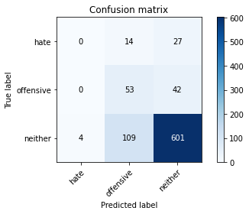

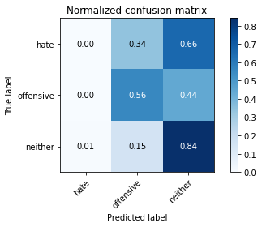

precision recall f1-score support

hate 0.00 0.00 0.00 41

offensive 0.30 0.56 0.39 95

neither 0.90 0.84 0.87 714

accuracy 0.77 850

macro avg 0.40 0.47 0.42 850

weighted avg 0.79 0.77 0.77 850

average eval_loss: 0.574590474020603, accuracy: 0.7694117647058824

training 4 epoch...

7.918589353561401 seconds used......

4 training finished! average train loss: 0.43933897525072096

evaluating...

Confusion matrix, without normalization

[[ 5 22 14]

[ 3 82 10]

[ 20 198 496]]

Normalized confusion matrix

[[0.12195122 0.53658537 0.34146341]

[0.03157895 0.86315789 0.10526316]

[0.0280112 0.27731092 0.69467787]]

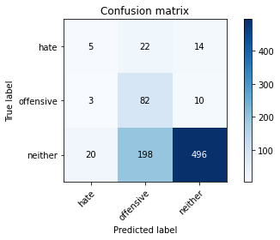

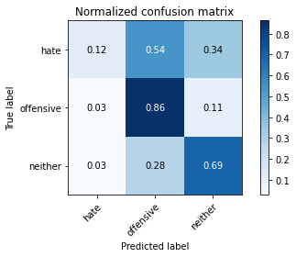

precision recall f1-score support

hate 0.18 0.12 0.14 41

offensive 0.27 0.86 0.41 95

neither 0.95 0.69 0.80 714

accuracy 0.69 850

macro avg 0.47 0.56 0.45 850

weighted avg 0.84 0.69 0.73 850

average eval_loss: 0.8041510835809763, accuracy: 0.6858823529411765

training 5 epoch...

7.89612340927124 seconds used......

5 training finished! average train loss: 0.24214581534266472

evaluating...

Confusion matrix, without normalization

[[ 5 15 21]

[ 4 63 28]

[ 20 140 554]]

Normalized confusion matrix

[[0.12195122 0.36585366 0.51219512]

[0.04210526 0.66315789 0.29473684]

[0.0280112 0.19607843 0.77591036]]

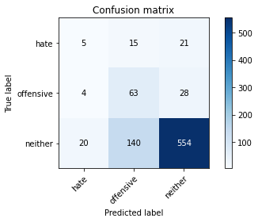

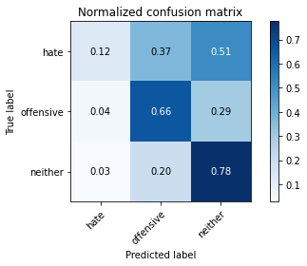

precision recall f1-score support

hate 0.17 0.12 0.14 41

offensive 0.29 0.66 0.40 95

neither 0.92 0.78 0.84 714

accuracy 0.73 850

macro avg 0.46 0.52 0.46 850

weighted avg 0.81 0.73 0.76 850

average eval_loss: 0.7787642273835318, accuracy: 0.731764705882353

training 6 epoch...

7.899778604507446 seconds used......

6 training finished! average train loss: 0.11461109399795533

evaluating...

Confusion matrix, without normalization

[[ 10 8 23]

[ 5 60 30]

[ 35 108 571]]

Normalized confusion matrix

[[0.24390244 0.19512195 0.56097561]

[0.05263158 0.63157895 0.31578947]

[0.04901961 0.1512605 0.79971989]]

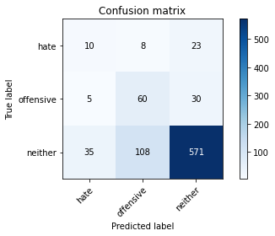

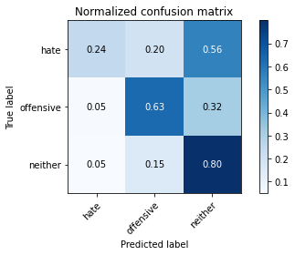

precision recall f1-score support

hate 0.20 0.24 0.22 41

offensive 0.34 0.63 0.44 95

neither 0.92 0.80 0.85 714

accuracy 0.75 850

macro avg 0.49 0.56 0.51 850

weighted avg 0.82 0.75 0.78 850

average eval_loss: 0.7956544618273891, accuracy: 0.7541176470588236

training 7 epoch...

7.9187352657318115 seconds used......

7 training finished! average train loss: 0.04262471256777644

evaluating...

Confusion matrix, without normalization

[[ 6 12 23]

[ 3 56 36]

[ 16 108 590]]

Normalized confusion matrix

[[0.14634146 0.29268293 0.56097561]

[0.03157895 0.58947368 0.37894737]

[0.02240896 0.1512605 0.82633053]]

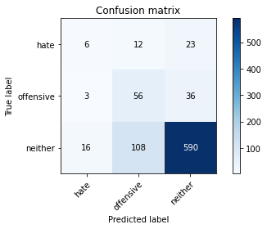

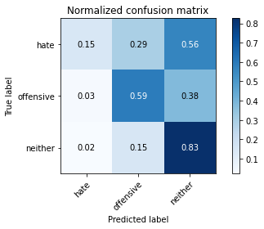

precision recall f1-score support

hate 0.24 0.15 0.18 41

offensive 0.32 0.59 0.41 95

neither 0.91 0.83 0.87 714

accuracy 0.77 850

macro avg 0.49 0.52 0.49 850

weighted avg 0.81 0.77 0.78 850

average eval_loss: 0.844940202649098, accuracy: 0.7670588235294118

training 8 epoch...

7.897974967956543 seconds used......

8 training finished! average train loss: 0.022777327485382557

evaluating...

Confusion matrix, without normalization

[[ 7 10 24]

[ 3 58 34]

[ 15 110 589]]

Normalized confusion matrix

[[0.17073171 0.24390244 0.58536585]

[0.03157895 0.61052632 0.35789474]

[0.0210084 0.15406162 0.82492997]]

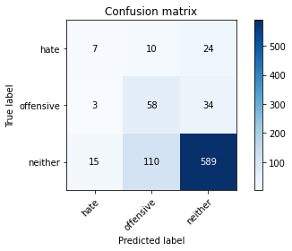

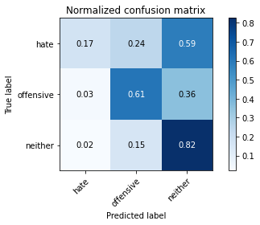

precision recall f1-score support

hate 0.28 0.17 0.21 41

offensive 0.33 0.61 0.42 95

neither 0.91 0.82 0.87 714

accuracy 0.77 850

macro avg 0.51 0.54 0.50 850

weighted avg 0.81 0.77 0.78 850

average eval_loss: 0.8691987341789659, accuracy: 0.7694117647058824

training 9 epoch...

7.952401161193848 seconds used......

9 training finished! average train loss: 0.008972265250049532

evaluating...

Confusion matrix, without normalization

[[ 9 7 25]

[ 5 52 38]

[ 28 96 590]]

Normalized confusion matrix

[[0.2195122 0.17073171 0.6097561 ]

[0.05263158 0.54736842 0.4 ]

[0.03921569 0.13445378 0.82633053]]

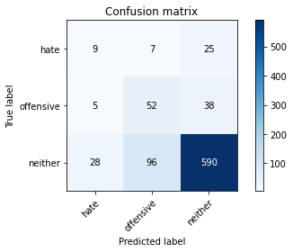

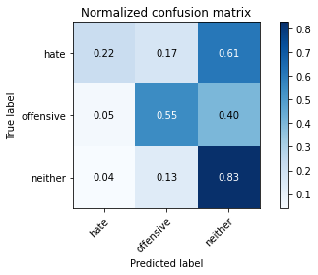

precision recall f1-score support

hate 0.21 0.22 0.22 41

offensive 0.34 0.55 0.42 95

neither 0.90 0.83 0.86 714

accuracy 0.77 850

macro avg 0.48 0.53 0.50 850

weighted avg 0.81 0.77 0.78 850

average eval_loss: 0.9193052051664699, accuracy: 0.7658823529411765

training 10 epoch...

7.893662452697754 seconds used......

10 training finished! average train loss: 0.006838464923202991

evaluating...

Confusion matrix, without normalization

[[ 5 11 25]

[ 1 62 32]

[ 13 115 586]]

Normalized confusion matrix

[[0.12195122 0.26829268 0.6097561 ]

[0.01052632 0.65263158 0.33684211]

[0.01820728 0.16106443 0.82072829]]

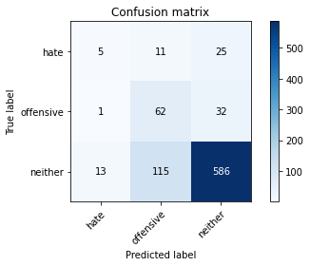

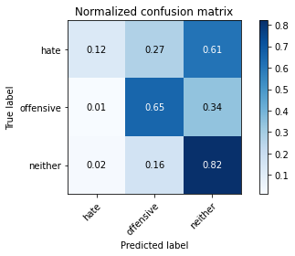

precision recall f1-score support

hate 0.26 0.12 0.17 41

offensive 0.33 0.65 0.44 95

neither 0.91 0.82 0.86 714

accuracy 0.77 850

macro avg 0.50 0.53 0.49 850

weighted avg 0.82 0.77 0.78 850

average eval_loss: 0.9846713286120617, accuracy: 0.768235294117647

5 run......

training 1 epoch...

7.904057741165161 seconds used......

1 training finished! average train loss: 0.9946126914024354

evaluating...

Confusion matrix, without normalization

[[ 0 14 27]

[ 0 10 85]

[ 0 76 638]]

Normalized confusion matrix

[[0. 0.34146341 0.65853659]

[0. 0.10526316 0.89473684]

[0. 0.10644258 0.89355742]]

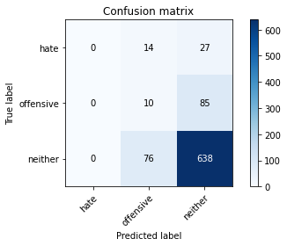

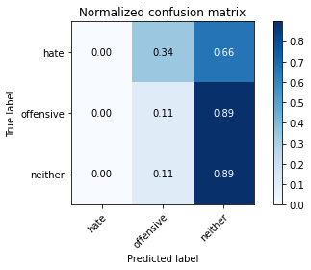

/opt/conda/lib/python3.7/site-packages/sklearn/metrics/_classification.py:1245: UndefinedMetricWarning: Precision and F-score are ill-defined and being set to 0.0 in labels with no predicted samples. Use `zero_division` parameter to control this behavior.

_warn_prf(average, modifier, msg_start, len(result))

/opt/conda/lib/python3.7/site-packages/sklearn/metrics/_classification.py:1245: UndefinedMetricWarning: Precision and F-score are ill-defined and being set to 0.0 in labels with no predicted samples. Use `zero_division` parameter to control this behavior.

_warn_prf(average, modifier, msg_start, len(result))

/opt/conda/lib/python3.7/site-packages/sklearn/metrics/_classification.py:1245: UndefinedMetricWarning: Precision and F-score are ill-defined and being set to 0.0 in labels with no predicted samples. Use `zero_division` parameter to control this behavior.

_warn_prf(average, modifier, msg_start, len(result))

precision recall f1-score support

hate 0.00 0.00 0.00 41

offensive 0.10 0.11 0.10 95

neither 0.85 0.89 0.87 714

accuracy 0.76 850

macro avg 0.32 0.33 0.32 850

weighted avg 0.73 0.76 0.74 850

average eval_loss: 0.7588607086691745, accuracy: 0.7623529411764706

training 2 epoch...

7.955873250961304 seconds used......

2 training finished! average train loss: 0.7958925950527191

evaluating...

Confusion matrix, without normalization

[[ 0 22 19]

[ 0 55 40]

[ 1 176 537]]

Normalized confusion matrix

[[0. 0.53658537 0.46341463]

[0. 0.57894737 0.42105263]

[0.00140056 0.2464986 0.75210084]]

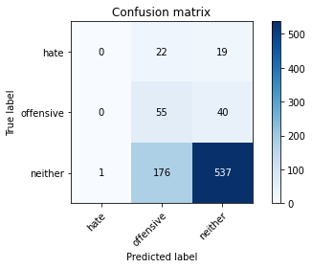

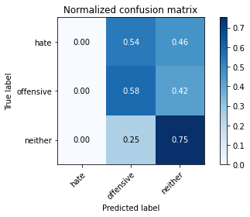

precision recall f1-score support

hate 0.00 0.00 0.00 41

offensive 0.22 0.58 0.32 95

neither 0.90 0.75 0.82 714

accuracy 0.70 850

macro avg 0.37 0.44 0.38 850

weighted avg 0.78 0.70 0.72 850

average eval_loss: 0.7388601429587187, accuracy: 0.6964705882352941

training 3 epoch...

7.904033899307251 seconds used......

3 training finished! average train loss: 0.6253920060396194

evaluating...

Confusion matrix, without normalization

[[ 0 16 25]

[ 5 58 32]

[ 22 113 579]]

Normalized confusion matrix

[[0. 0.3902439 0.6097561 ]

[0.05263158 0.61052632 0.33684211]

[0.03081232 0.15826331 0.81092437]]

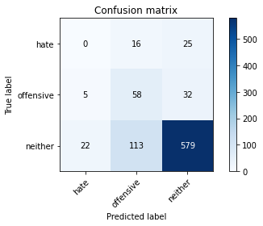

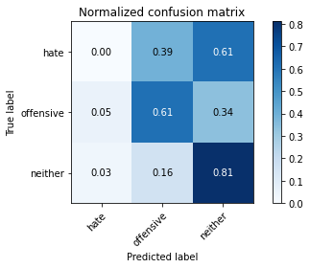

precision recall f1-score support

hate 0.00 0.00 0.00 41

offensive 0.31 0.61 0.41 95

neither 0.91 0.81 0.86 714

accuracy 0.75 850

macro avg 0.41 0.47 0.42 850

weighted avg 0.80 0.75 0.77 850

average eval_loss: 0.657953153515971, accuracy: 0.7494117647058823

training 4 epoch...

7.874346494674683 seconds used......

4 training finished! average train loss: 0.4531702941656113

evaluating...

Confusion matrix, without normalization

[[ 5 6 30]

[ 7 19 69]

[ 15 40 659]]

Normalized confusion matrix

[[0.12195122 0.14634146 0.73170732]

[0.07368421 0.2 0.72631579]

[0.0210084 0.05602241 0.92296919]]

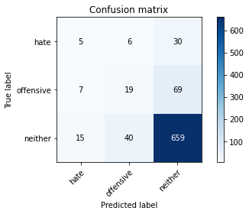

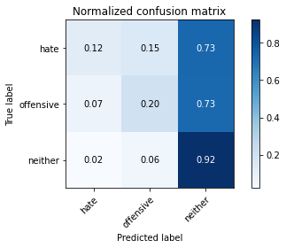

precision recall f1-score support

hate 0.19 0.12 0.15 41

offensive 0.29 0.20 0.24 95

neither 0.87 0.92 0.90 714

accuracy 0.80 850

macro avg 0.45 0.41 0.43 850

weighted avg 0.77 0.80 0.79 850

average eval_loss: 0.5664756692686054, accuracy: 0.8035294117647059

training 5 epoch...

7.885324716567993 seconds used......

5 training finished! average train loss: 0.26725621610879896

evaluating...

Confusion matrix, without normalization

[[ 0 15 26]

[ 6 56 33]

[ 13 108 593]]

Normalized confusion matrix

[[0. 0.36585366 0.63414634]

[0.06315789 0.58947368 0.34736842]

[0.01820728 0.1512605 0.83053221]]

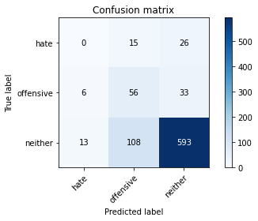

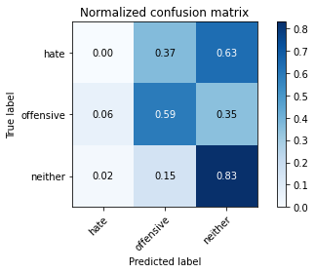

precision recall f1-score support

hate 0.00 0.00 0.00 41

offensive 0.31 0.59 0.41 95

neither 0.91 0.83 0.87 714

accuracy 0.76 850

macro avg 0.41 0.47 0.43 850

weighted avg 0.80 0.76 0.77 850

average eval_loss: 0.7051111490054186, accuracy: 0.7635294117647059

training 6 epoch...

7.874917984008789 seconds used......

6 training finished! average train loss: 0.12871310777962208

evaluating...

Confusion matrix, without normalization

[[ 1 10 30]

[ 2 46 47]

[ 9 75 630]]

Normalized confusion matrix

[[0.02439024 0.24390244 0.73170732]

[0.02105263 0.48421053 0.49473684]

[0.01260504 0.10504202 0.88235294]]

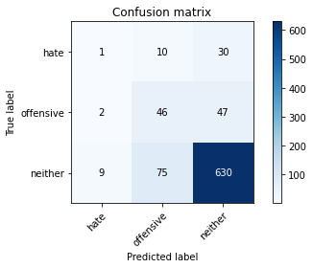

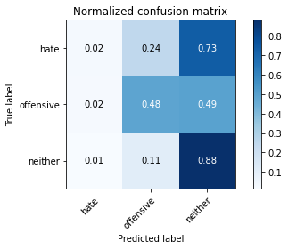

precision recall f1-score support

hate 0.08 0.02 0.04 41

offensive 0.35 0.48 0.41 95

neither 0.89 0.88 0.89 714

accuracy 0.80 850

macro avg 0.44 0.46 0.44 850

weighted avg 0.79 0.80 0.79 850

average eval_loss: 0.706191009782298, accuracy: 0.7964705882352942

training 7 epoch...

7.922414064407349 seconds used......

7 training finished! average train loss: 0.05430940480902791

evaluating...

Confusion matrix, without normalization

[[ 9 8 24]

[ 14 56 25]

[ 64 90 560]]

Normalized confusion matrix

[[0.2195122 0.19512195 0.58536585]

[0.14736842 0.58947368 0.26315789]

[0.08963585 0.12605042 0.78431373]]

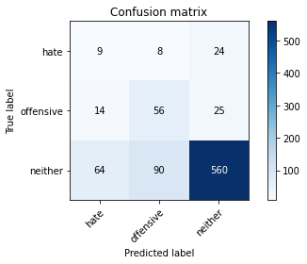

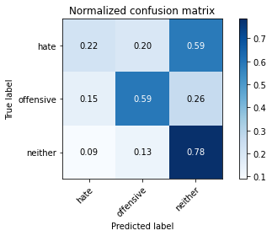

precision recall f1-score support

hate 0.10 0.22 0.14 41

offensive 0.36 0.59 0.45 95

neither 0.92 0.78 0.85 714

accuracy 0.74 850

macro avg 0.46 0.53 0.48 850

weighted avg 0.82 0.74 0.77 850

average eval_loss: 0.9729278556769714, accuracy: 0.7352941176470589

training 8 epoch...

7.907222509384155 seconds used......

8 training finished! average train loss: 0.023478651703335345

evaluating...

Confusion matrix, without normalization

[[ 2 13 26]

[ 5 51 39]

[ 22 122 570]]

Normalized confusion matrix

[[0.04878049 0.31707317 0.63414634]

[0.05263158 0.53684211 0.41052632]

[0.03081232 0.17086835 0.79831933]]

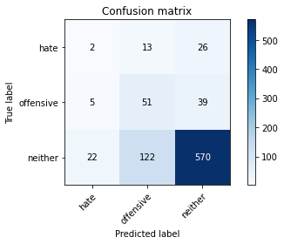

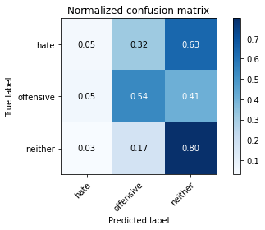

precision recall f1-score support

hate 0.07 0.05 0.06 41

offensive 0.27 0.54 0.36 95

neither 0.90 0.80 0.85 714

accuracy 0.73 850

macro avg 0.41 0.46 0.42 850

weighted avg 0.79 0.73 0.75 850

average eval_loss: 1.0551740981199844, accuracy: 0.7329411764705882

training 9 epoch...

7.9274537563323975 seconds used......

9 training finished! average train loss: 0.01334603026509285

evaluating...

Confusion matrix, without normalization

[[ 6 10 25]

[ 6 51 38]

[ 36 100 578]]

Normalized confusion matrix

[[0.14634146 0.24390244 0.6097561 ]

[0.06315789 0.53684211 0.4 ]

[0.05042017 0.14005602 0.80952381]]

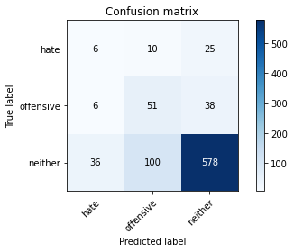

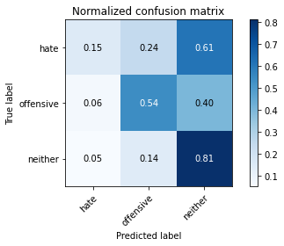

precision recall f1-score support

hate 0.12 0.15 0.13 41

offensive 0.32 0.54 0.40 95

neither 0.90 0.81 0.85 714

accuracy 0.75 850

macro avg 0.45 0.50 0.46 850

weighted avg 0.80 0.75 0.77 850

average eval_loss: 1.060196027216545, accuracy: 0.7470588235294118

training 10 epoch...

8.006767511367798 seconds used......

10 training finished! average train loss: 0.004743534515146166

evaluating...

Confusion matrix, without normalization

[[ 4 12 25]

[ 5 51 39]

[ 32 100 582]]

Normalized confusion matrix

[[0.09756098 0.29268293 0.6097561 ]

[0.05263158 0.53684211 0.41052632]

[0.04481793 0.14005602 0.81512605]]

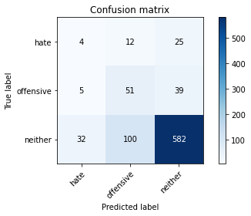

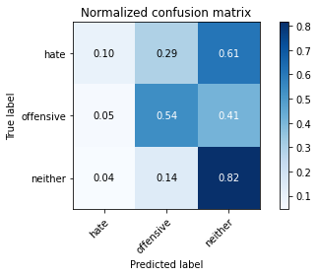

precision recall f1-score support

hate 0.10 0.10 0.10 41

offensive 0.31 0.54 0.40 95

neither 0.90 0.82 0.86 714

accuracy 0.75 850

macro avg 0.44 0.48 0.45 850

weighted avg 0.80 0.75 0.77 850

average eval_loss: 1.136894546714503, accuracy: 0.7494117647058823